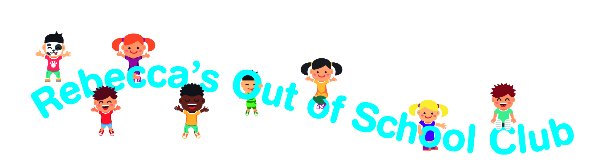

Out of School Club

Privacy Notice
At Rebeccas out of School Club we respect the privacy of the children attending the Club and the privacy of their parents or carers. The personal information that we collect about you and your child is used only to provide appropriate care for them, maintain our service to you, and communicate with you effectively. Our legal basis for processing the personal information relating to you and your child is so that we can fulfil our contract with you.
Any information that you provide is kept secure. Once a child leaves our care we retain only the data required by staturory legislation and industry best practice, e.g. accident forms and attendance lists, and for the prescribed periods of time. Electronic data that is no longer required is deleted and paper records are disposed of securely.
We will use the contact details you give us to contact you via phone, email, and post, so that we can send you information about your child, our Club and other relevant news, and also so that we can communicate with you regarding payment of our fees.
We will only share personal information about you or your child with another organisation if we:
- have a safeguarding concern about your child
- are required to by government bodies or law enforcement agencies
- engage a supplier to process data on our behalf (eg to take online bookings, or to issue invoices)
- have obtained your prior permission.
You have the right to ask to see the data that we have about yourself or your child, and to ask for any errors to be corrected. Please complete the Access Request Form on the website. We will respond to all such requests within one month. You can also ask for the data to be deleted, but note that:
- we will not be able to continue to care for your child if we do not have sufficient information about them
- even after your child has left our care, we have a statutory duty to retain some types of data for specific periods of time so can’t delete everything immediately.
If you have a complaint about how we have kept your information secure, or how we have responded to a request to access, update or erase your data, you can refer us to the Information Commissioner’s Office (ICO).
Please sign and date below to confirm that you have read this Privacy Notice and that you give your permission for us to contact you regarding relevant matters.

Signed: Date:
Name:

